Visual Analysis
Shenavia Lewis
DFC 630 9040 Digital Forensic Response and Analysis
August 22, 2017

Introduction Example
With any technological device today, various data is collected in the form of logs that can then be used by analysts during investigations. Logs can be turned off, but many people don’t realize the number of devices that automatically collect information. A few of these devices include, computers and laptops, identification scanning systems, cars, cell phone towers, and GPS applications. All of the data collected from these systems can be used to prove a suspect guilty or innocent during a case and can be very beneficial. What is now realized, however, is the amount of data that is being logged. For instance, every time a person scans their badge to get in and out of different rooms in their workplace, a log is automatically getting built with the data for that one person. Now, multiply that data by 1,000 people in a building, for example, and the data is voluminous. In the event of a crime where analysts have to sift through different device data to find the right information, patterns, and answers, the time this could take is endless. That reason alone, is why visual analysis is a necessity.
Problems that can arise when analysis and tasked with processing and analyzing large volumes of forensic data.
Analysts are tasked with analyzing and processing large volumes of forensic data, so many problems will occur. These can be grouped into three categories: process challenges, management challenges, and data challenges.
Process Challenges
When discussing process challenges, it involves picking the right model for the analysis of the data, provision of results and data transformation. To deal with large volumes of data is problematic. A forensic scientist is likely to take care of the whole process and give correct information. As a result, it may not be convincing forcing the scientist to go through the process repeatedly which can be draining considering the large amount of data (Quick & Choo, 2014).
Management Challenges
management challenges may have issues such as privacy and data security. Dealing with a large amount of data from unauthorized access can be difficult. Reason for that is, this sort of data can be conspicuous and calls for all attention. Individuals that are unauthorized may accidentally access it and can ruined confidentially (Tole, 2013). The situational can be worse in a case where the data is in physical form. This can mean it can easily be ported from one individual to another individual through planned leakage. These issues can be controlled by a forensic scientist that chooses to deal with the data in small bits.
Data Challenges
Data challenges has issues such as discovery, variety rise and data volume. Since the volume of data is large, it will be expensive to process. The reason for that is, computers can help in data processing and there must be an individual to start the whole process. The more the data is the more work it will be. The work will be difficult for a forensic scientist to try to organize and find out how they all can relate (Quick & Choo, 2014).
Visual Analysis Techniques
The visual analysis is an art of engaging in different observations through external features in some cases without the use of instruments. This would keep with a general estimate which can be used for different studies. Visual analysis can also be referred to visual inspection that is based on improving the visual literally and communication. It can be overwhelming task due to the complexity of the data that is involved. It also focusses on fields such as the information that is based on visualization and the visualization of the scientific subject using analytical reasoning which can be facilitated by using the interactive interface (Lane & Gast, 2014). Information visualization represents the data from the obstruct by reinforcing the cognition from individuals. The data that is from the obstruct entails both the numerical type of data and the non-numeric type of data that would include the geographical information and texts (Kratochwill, 2015).
Techniques of Visual Analysis
There are different types of techniques that can be used on analyzing the visualization that would include filtering, link analysis and time analysis.
Filtering
Data filtering is a very useful technique in visual analysis. It entails the use of auto filters or built data that uses the comparison operates to analyze data that is visually. There are so many different types of filters that are used that includes the storage format filters. The filtering process of data includes the following processes like, evaluating both the time and numbers of filters and selecting the data that issues filtration. In some cases, the data sources are made of many quantities of large data. The reports require certain data to meet some conditions by setting the records that should be used for recording purposes (Lane & Gast, 2014). This can help create efficient and important designs. For example, when looking through a suspect’s bank records, a filter could be used to look for activity within a certain time period, a common amount, or a specific description. This could change a 1,000-character list into a list of 10 in a matter of seconds. Another bonus to the filtering technique is that multiple filters can be placed on the data so that a filter does not exclude any important information. Filtering can also be used as evidence within the timeline analysis.
Link Analysis
Link analysis is a common used analysis that is used for the network processor in the data visualization analysis. This will enhance the social network analysis which can enhance the organizations and transactions. This will also help the simplification of data that can help in a good way in visualization of data (Kehrer & Hauser, 2013). The data visualization is very important for large amount of data. It helps to achieve the search engine in data analysis in the market research and different entities. This can be work between objectives that would make it easy for evaluation with the achievement of establishing patterns that are new intelligence, social networking and marketing.
Timeline analysis
Timeline analysis is another technique that can be used for visual analysis that would help in the investigation and build strong interfaces in timelines. The timeline analysis can also help in forensic analysis as well.
Technique of Visual Analysis Application
The filtering analysis plans an important role in ensuring that all the data is well analyzed for making informed decisions making process. One of the application in filtering analysis in the processing of data is the amplification of the sound in electronic which can enable the users to obtain the quality of sound. Another area of filtering analysis is reorganization of data by making the analysis of large data easy and faster time.
Case
The analysis that would contain revenue data is grouped by the category attribute that would allow the company to display the revenue for different products. For example, the revenue for books as well as movies.
Link Analysis
Link analysis is another visual analysis that would play an integral role in data analysis. The application of link analysis is visualization of data to have better data as well as relationship links. Engine optimization is another application of link analysis. This type of application, the large data may be analyzed easily for decision making processes efficient and effective.
Case
Fraud Decision
The link analysis is applicable in insurance companies. The link analysis data is collated on a huge scale and sorted in three categories: Fraud, unsure and not fraud. This is applied in the real world in situation where the companies have many data that is require in fraud investigation.
Timeline Analysis
Timeline analysis is capable in various places in data analysis process in the organization. One of them is in investigation and building up strong interfaces which is very important in the data analysis. The visual analysis techniques are important in the process of analyzing data in the organization. This is important for the organization to adopt this technique for making accurate decisions.
Case
In real life, the timeline analysis can be used in experimenting timelines for artifacts analysis. This is applied in classifications of chronological manner which would make understanding easy by the users.
2015 Paris ISIS Attacks
Overview
127 individuals were murdered by a French president
Description of the incident
Among with the dead, there were two Belgians, a Swedish resident and two Romanians. Eight assailants were killed by their explosive suicide belts. Two hundred individuals were injured. The shootings and blasts were over six areas over the city that included the state de France in northern Paris, where the two suicide assaults and a besieging has occurred as the national group had played in Germany in a well-planned football coordinate.
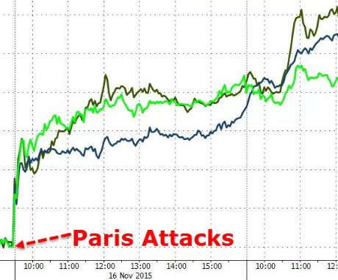
Good example
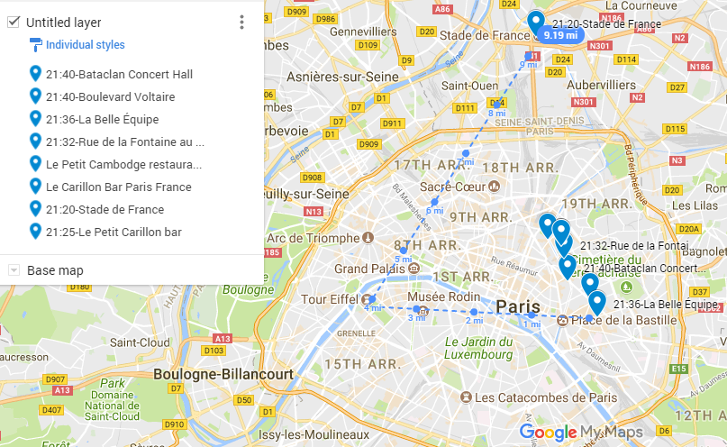
Description by use of Maltego
The major part of the casualty was after a mass shooting inside the Beta clan show scene. The shootings occurred in different destinations in the focal point of the city. President Holland who was at the state de France during the attacks stated, “We will lead a war for such monstrosities that they decided France, a unified France, a France that is as one and does not give itself a chance to be moved, regardless of the possibility that today we express interminable distress”.
A situation has been introduced over France and the security in the nation’s outskirts has been fixed. Paris occupants was told to stay in their homes and the specialists said that, “the greatest part of the city luxuries”, includes colleges, libraries, swimming pools will be closed on Saturday. Australian Malcolm Turnbull states that “seems to have every one of the signs of a Daesh (Islamic state) workout”. Hassan Rouhani (Iran leader) had stop his visited to France because of what had happen one week from the of the psychological assaults. Bae Ki-moon (UN boss) states “the wretched psychological assaults were completed in various areas in and around Paris” and had requested “the prompt arrival of the different people being held prisoner in the Beta clan theater. Charles Michel (Belgian head administrator) had wanted his subjects to abstain from going to Paris. He also mentioned that security will be ventured to open during occasions in Belgium.
Conclusions
The police had gone through a Brussels neighborhood where the three of the assailants had lived and made different captures. One of the assailants at the Beta clan was captured who was a 30-year-old French national and was also known to the French police due to the connection to Islamic radicals. A Egyptian and a Syrian were also found on the assemblages of the two suicide planes. The Syrian traveler had a permit with a displaced person who had went through Greece as a Greek clergyman.
Maltego Graph:
This is an example of what you map should have looked like – 3 teams of Terrorists
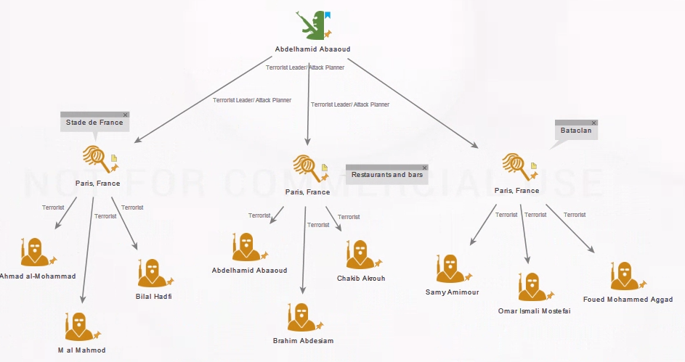
Map continued
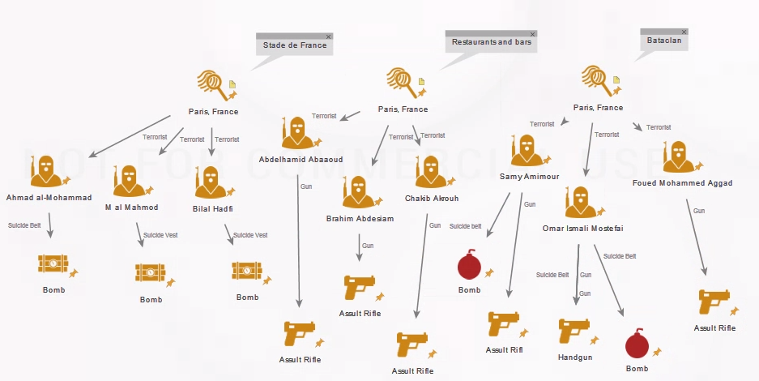
Weapons Breakdown
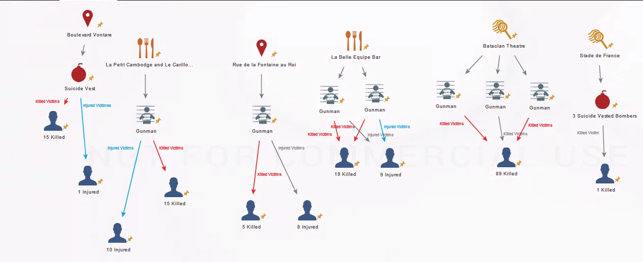
Causalities from Each Location
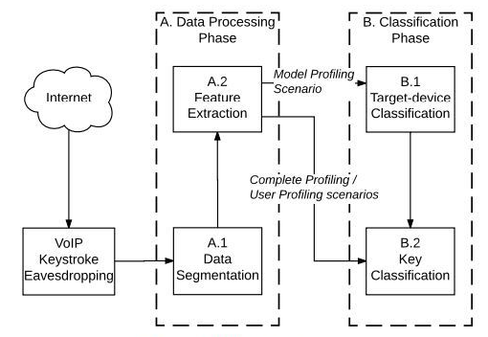
You have left out part of the assignment. – Step 5 – Develop Implementation Recommendations
In the course of your research, you have learned a lot about visual analysis tools, but this scenario asks you to close the deal with your supervisor’s boss. In other words, based on what you know now, which visual analysis tool(s) will best meet the needs of your department? To answer this question, you need to do a cost-benefit analysis that compares the costs of purchasing and implementing the tool(s) with benefits for your department and employer. Examples of benefits could include time and money savings, work quality, staff morale, and professional recognition. Base your ballpark projections on the project scenario and related research (in-class readings, outside resources). Conclude this section of your paper with recommendations for the use of visual analysis tools in this scenario.
The presentation of your analysis and recommendations should be two to three pages. Be sure to use APA format and write so that a nonexpert can understand your recommendations. Review your paper carefully for accuracy and completeness. It will serve as the fifth and final section of the white paper to be submitted in the final step.

References
Chaliand, G., & Blin, A. (2007). The history of terrorism: From antiquity to al Qaeda. Berkeley: University of California Press. Retrieved on August 22, 2017
Crenshaw, M., & LaFree, G. (2016). Countering terrorism: No simple solutions. Place of publication not identified: Brookings Institution Press. Retrieved on August 22, 2017
Kepel, G., & Jardin, A. (2017). Terror in France: The rise of jihad in the west. Retrieved on August 22, 2017
McCants, W. F. (2015). The ISIS apocalypse: The history, strategy, and doomsday vision of the Islamic State. Retrieved on August 22, 2017

